How to book an appointment at the Learning Centre using Blackboard

This guide was designed for current full time and part time students of Seneca@York campus who want to book appointments for tutoring sessions at the Learning Centre using Blackboard.

# Overview

Learning Centre at Seneca@York campus is a one stop location that offers academic support to active students, full time and part time, through one-to-one or group tutoring and workshops. They help students improve their understanding on major concepts on their courses by adapting different strategies that suits the learning style of each student.

The Learning Centre at Seneca@York campus is located at Stephen E. Quinlan building at the west wing of the library. Every student currently enrolled must make an appointment using Blackboard in order to access the services offered by the Learning Centre.

## Description of Operation

The Learning Centre at Seneca@York campus is operating from 9am to 6pm, Monday thru Friday. Students who made appointments prior to their visits will be served in high priority at the Learning Centre. Students who doesn’t have appointments will not be accommodated unless a tutor becomes available during their visits. Appointments at the Learning Centre can be booked 7 days in advance or earlier depending on availability of tutors. Each student is allowed to book 30 minutes to 1-hour maximum *per course* and maximum 3 appointments *per week*.

This guide provides students simplified steps to create appointments at the Learning Centre using Blackboard in just a few clicks of a mouse or a few taps on touch screen devices.

### Warning/Tip

***Note:*** Stable internet connection is required at the time of booking in order to create an appointment in Blackboard. If request fails, check internet connection before making another request.

***Warning:*** To prevent identity theft, always secure usernames and passwords when logging on the website especially in public area.

## Login to MySeneca Blackboard

MySeneca Blackboard is the main portal of students at Seneca@York to access information about the college, their individual financial accounts and school records, and to book appointments for services offered by different offices at the college. This portal can only be accessed using the SenecaID and password provided to each student.

1. Open the MySeneca Blackboard website ( <https://my.senecacollege.ca> ) to any internet browser (e.g. Chrome, Firefox, Safari, etc.).
2. Enter your SenecaID and password to login. (Figure 1)

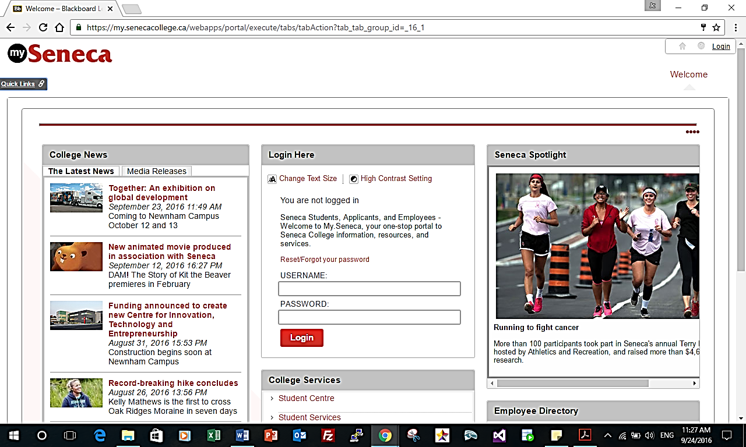

**Figure 1: Login to MySeneca Blackboard**

## Open the appointment system of the Learning Centre

Login to MySeneca Blackboard using your SenecaID and password. To book an appointment with Learning Center, you need to do few more clicks on your mouse or taps on your touch screen devices to enter the Learning Centre’s appointment system.

1. After logged in at MySeneca Blackboard, click/tap the Student tab at the menu to open the different services for students. (Figure 2)

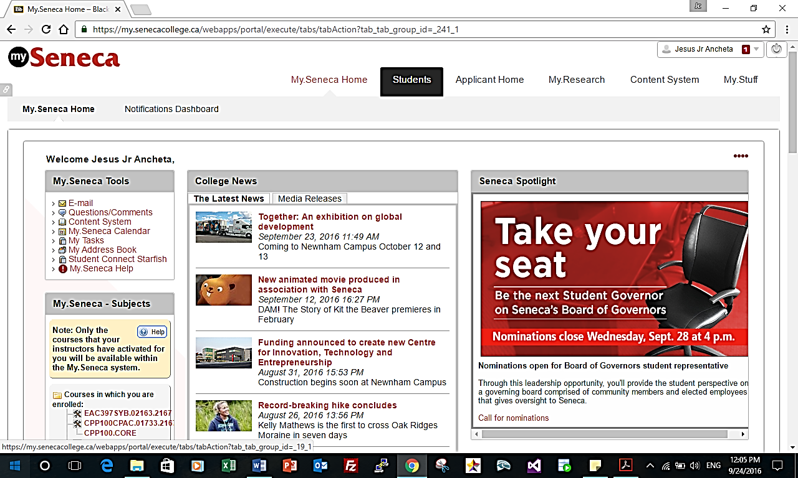

**Figure 2: Different services for students**

1. On the new page, look for the “**Learning Centre - Tutor Book”** section located at the left side.
2. Click/tap the Seneca@York link under “**Tutor Booking”** to open the appointment system of the Learning Centre at Seneca@York. (Figure 3)

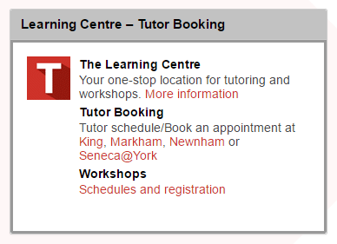

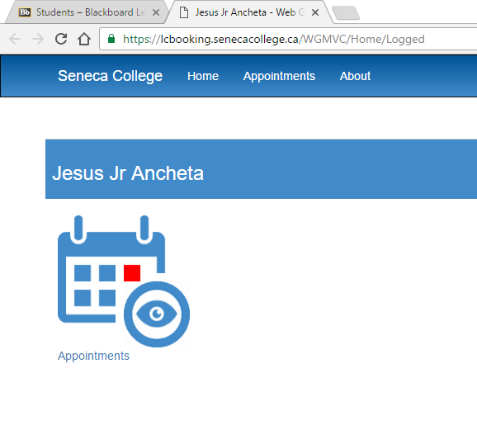

**Name of Student**

**Figure 3: Seneca@York appointment system**

## Create new appointment

To create a new appointment with a tutor for a specific course at the Learning Centre, follow these simple steps.

1. Click/tap on the “**Appointments”** icon and followed by another click/tap on another icon for “**Create Appointment Students”.**
2. Select “**Seneca@York Campus”** for category field and the course that you want for tutoring.
3. Once selection for campus and course is done, click/tap “**Next”** button located below. (Figure 4)

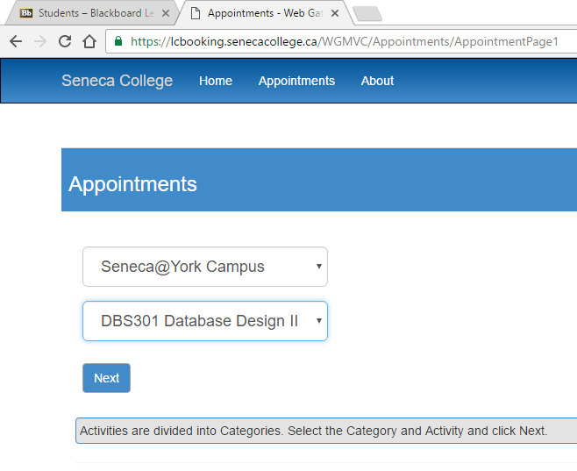

**Figure 4: Select campus and course**

## Select tutor, time and date of the appointment

By default, the appointment system of the Learning Centre will display a 1-week period starting from the current date. You can change the date range within the 1-week period depending on your required date of your appointment.

1. Change the date range as per your requirement.
2. Select the name of tutor to check its availability based on your selected date.
3. Click/tap the desired start time of your appointment with the tutor. (Figure 5)

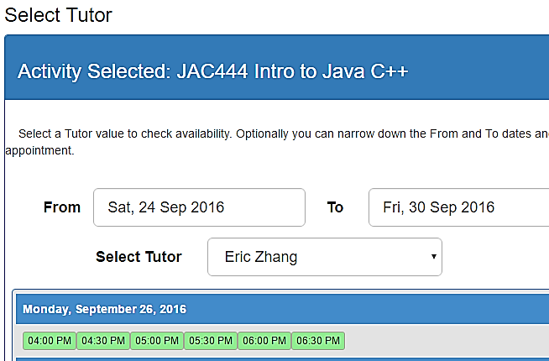

**Name of Tutor**

**Figure 5: Date and time of appointment with a tutor**

1. A small window will appear on your screen with all the details of your appointment. You can adjust the default end time of your appointment to a maximum of 1 hour by clicking the “**End”** field on the small window.
2. Review the details of your appointment and click the “**Schedule”** button to create the appointment in the system. (Figure 6)

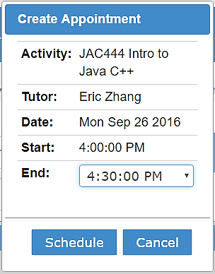

**Name of Tutor**

**Figure 6: Confirm appointment**

## Conclusion

Once completed above procedures, a confirmation email will be sent to the student’s email address which include the appointment details.

For more information, visit the Learning Centre website <https://inside.senecacollege.ca/learningcentres> or contact them at [learningcentre@senecacollege.ca](mailto:learningcentre@senecacollege.ca).